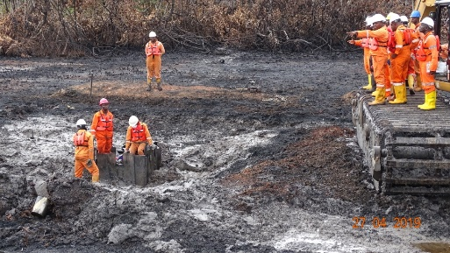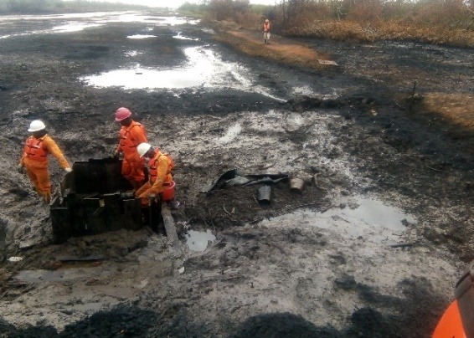
Spill point after exposure showing local coffer dam and burnt water pump. 4 Nos metal buckets at the spill point

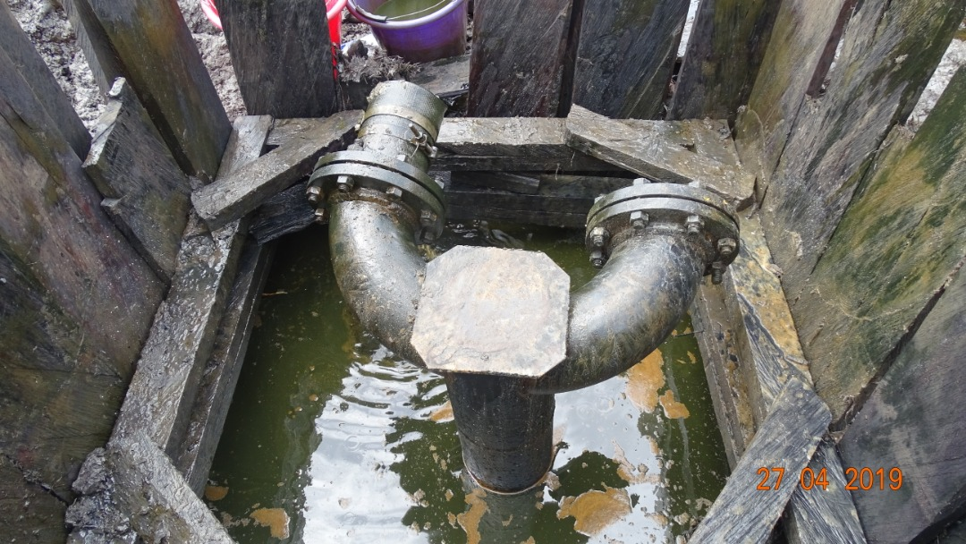
Spill Point after exposure showing installation on NCTL

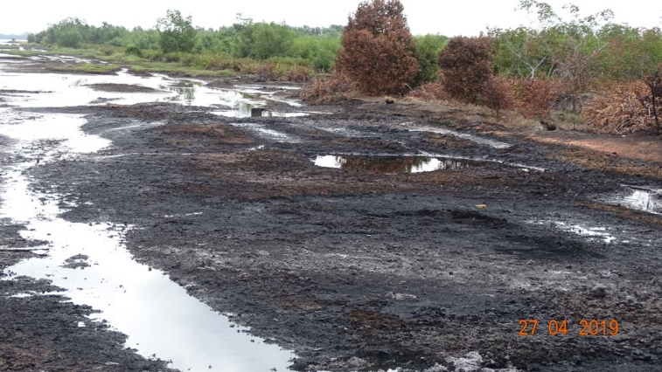
Burnt vegetation and carbonized soil around the spill point

